# Media Analysis - No need to demonize ChatGPT but AI regulation is a must _ Arab News

## Short Summary

The article is about the dual potential of ChatGPT to revolutionize various fields, including journalism, education, medicine, and literature, while also raising concerns over job displacement and ethical issues, emphasizing the need for AI regulation.

## Summary

- ChatGPT, developed by OpenAI, is a large language model capable of understanding and responding to natural language, impacting various industries including journalism in Saudi Arabia.  
- While seen as an opportunity for human advancement, concerns exist about AI's potential threat to jobs across sectors such as education and journalism; educators are adapting with new methods like oral exams to mitigate cheating through AI use.  
- In the medical field, ChatGPT has shown capabilities, even passing parts of a US Medical Licensing Examination without training on biomedical data, highlighting both its potential and limitations in practice.  
- The need for AI regulation is emphasized to balance its benefits against risks, ensuring it does not disproportionately favor technological advancements over human work.

## Question 1

The text frames the discussion around ChatGPT using several recurring metaphors and themes:  
  
1. **Existential Threat vs. Opportunity**: ChatGPT is depicted as both a potential existential threat to human work, particularly in fields like journalism, education, and medicine, and an opportunity for advancement. This dual framing highlights the transformative impact of AI technology.  
  
2. **Revolutionary Change**: The language suggests that AI, especially tools like ChatGPT, are revolutionizing various industries by dramatically increasing efficiency—e.g., generating content or providing medical insights faster than humans can.  
  
3. **Technological Watershed**: There's a metaphorical reference to being at a "watershed historical moment," indicating significant change and the need for careful navigation in integrating AI into society.  
  
4. **Educational Disruption**: The text suggests that ChatGPT could disrupt traditional educational methods, likening its impact to an upheaval where conventional teaching and assessment might become obsolete or require major adaptation.  
  
5. **Ethical Dilemma and Regulation**: It introduces a metaphor of balance, indicating the need for regulation to prevent AI from tipping societal dynamics unfavorably.  
  
Overall, these metaphors collectively frame ChatGPT as both an innovative tool with immense potential benefits and a disruptive force that necessitates cautious integration into society.

## Question 2

The article covers several perspectives and aspects regarding the impact of AI, particularly ChatGPT, across various fields:  
  
### Widely Covered Aspects:  
1. **Educational Impact**:   
 - Potential for cheating and plagiarism.  
 - Transformations in teaching methods (oral exams, handwritten tests).  
 - Development of tools to detect AI-generated text.  
  
2. **Journalism**:  
 - Use of AI in writing articles, raising concerns about accuracy and originality.  
 - Fear of job displacement among journalists due to AI's capabilities.  
  
3. **Medical Field**:   
 - Potential for AI to assist or even outperform humans in tasks like medical diagnostics.  
 - Ethical considerations and current reliance on AI as an augmentative tool rather than a replacement.  
  
4. **Creativity and Literature**:  
 - Use of AI in generating creative content such as books, raising ethical and copyright issues.  
  
5. **General Opportunities and Threats**:   
 - AI's potential to democratize access to information and resources.  
 - The need for regulation to prevent AI from having adverse effects.  
  
### Aspects That Are Ignored or Less Emphasized:  
1. **Economic Impact**:  
 - How AI might influence job markets, beyond the immediate threat to specific professions.  
   
2. **Privacy Concerns**:  
 - Implications of data usage and privacy in training AI models like ChatGPT.  
  
3. **Long-term Societal Changes**:   
 - Broader societal transformations due to widespread AI adoption are not deeply explored.  
  
4. **Global Perspective**:  
 - While there is a mention of developing countries, the specific global implications or disparities caused by AI technology aren't extensively covered.  
  
5. **Technical Limitations and Improvements**:  
 - More detail on ChatGPT's limitations beyond being polite or occasionally confused could provide more insight into future improvements needed.  
  
The article provides a comprehensive overview while suggesting caution and regulation to mitigate risks associated with AI advancements.

## Question 3

The article does not specifically mention any roles or contributions of the Arabic world regarding leveraging AI, including ChatGPT. The discussion primarily revolves around general impacts and concerns related to AI's influence globally, without detailing specific actions or perspectives from the Arabic region.  
  
**Answer: Not mentioned**

## Question 4

The final message of the article emphasizes the need for AI regulation, particularly with tools like ChatGPT, to ensure balanced benefits across industries. While acknowledging its potential to advance various fields and equalize opportunities globally, the article warns against overhyping the threats it poses to human jobs. Proper regulations are necessary to prevent negative consequences and maintain a balance between leveraging AI advancements and protecting human roles.

## Sentiment

The sentiment is 3.0

## Entities

Arab News, Google, BBC, OpenAI, READ Learning, fed, The New York Times, Midjourney, AI, CNET, Springboard, Disclaimer Views, Generative Pretrained Transformer, The Washington Post, Post, Amal Mudallali

## Highlights

#7cc867: 31

#fb5b89: 50

#c885da: 19

#f9cd59: 33

## Wordcloud for #7cc867 Highlights

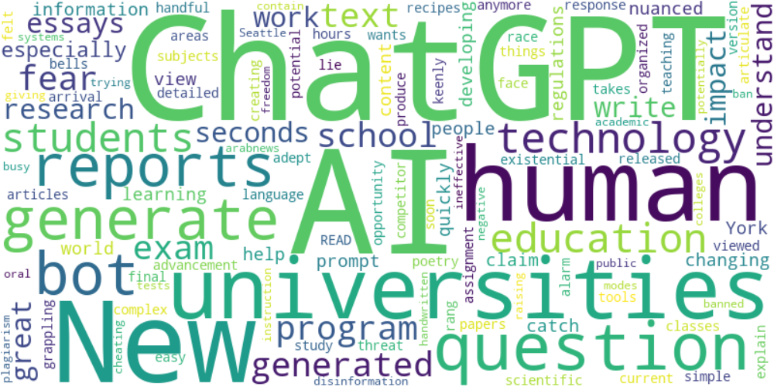

Top 10 words:

- ChatGPT: 9

- AI: 9

- human: 4

- reports: 3

- generate: 3

- bot: 3

- technology: 3

- education: 3

- universities: 3

- generated: 3

## Wordcloud for #fb5b89 Highlights

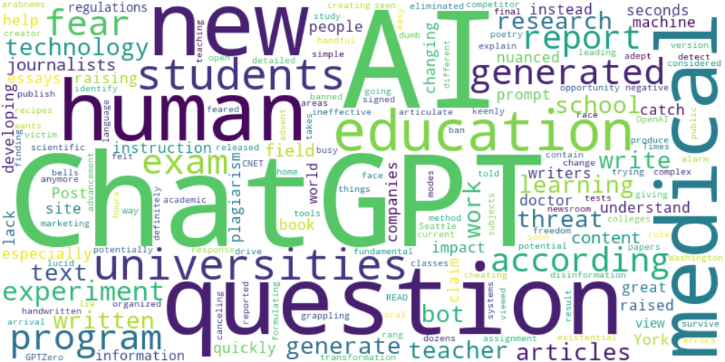

Top 10 words:

- AI: 18

- ChatGPT: 16

- human: 5

- education: 4

- question: 4

- generated: 4

- fear: 4

- questions: 4

- experiment: 4

- medical: 4

## Wordcloud for #c885da Highlights

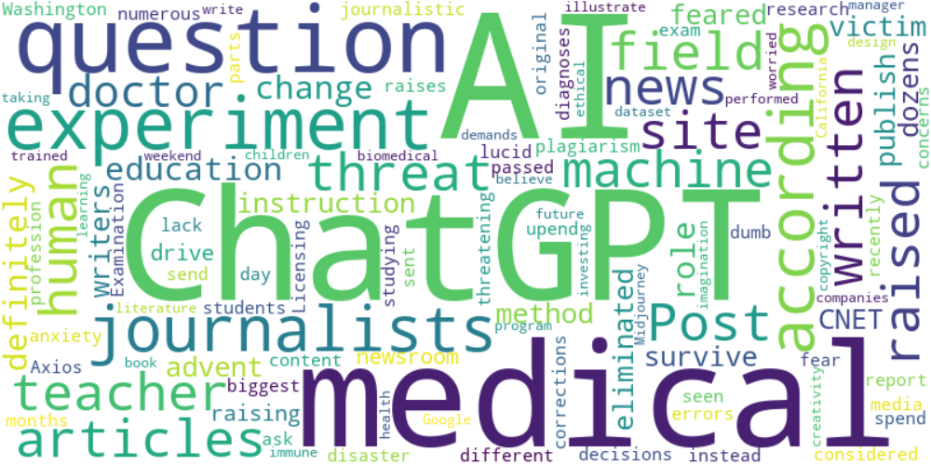

Top 10 words:

- AI: 9

- ChatGPT: 7

- experiment: 4

- medical: 4

- question: 3

- journalists: 3

- news: 2

- site: 2

- articles: 2

- according: 2

## Wordcloud for #f9cd59 Highlights

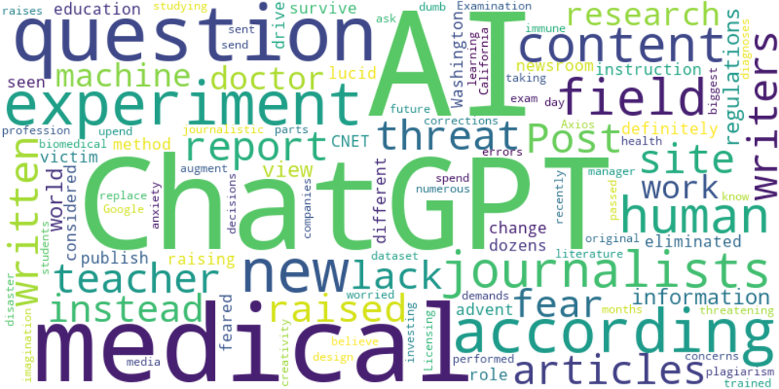

Top 10 words:

- AI: 12

- ChatGPT: 9

- experiment: 4

- medical: 4

- question: 3

- journalists: 3

- content: 3

- writers: 2

- news: 2

- site: 2